**ECEN 602**

**NETWORK SIMULATION ASSIGNMENT – 02**

**TEAM 17**

**Mohammad Faisal Khan**

**Amiya Ranjan Panda**

**INTRODUCTION**

We have implemented a client and server for a simple chat service.

It has been successfully compiled, executed and tested on gcc compiler (part of standard LINUX).

Common Errors and Catches:

-If data is not input correctly on the command line as per the ordering given below, it throws a segmentation error.

-This is NOT to be assumed as an error.

-If data is missing from the command line, it throws segmentation error too.

-If a user with a name same as an existing active chat room user joins, he will be required to reenter chat room using a valid name.

-Username can be any size until 512 characters.

-Maximum number of clients active on chat room = argv[3]. If argv[3]+1 client joins, it will throw an ERROR on server and client console.

-IMPORTANT: Please do not use same serverport when running server second time, until the first server process is killed (NOT SUSPENDED).

-If a client disconnects using keyword 'quit', a smooth disconnect happens and resources are deallocated. If not, the other clients enter into hang state.

-This is an iterative server, no use of fork() in this code.

Usage of MAKEFILE:

make -f makefile_server

make -f makefile_client

Then, EXECUTE using the following commands:

./team17_server <ip> <port> <max user>

Example - ./team17_server 127.0.0.1 50001 12

./team17_client <user name> <ip> <port>

Example - ./team17_client user1 127.0.0.1 50001

Usage:

All commands are executed on standard Terminal of LINUX which supports gcc compiler commands.

Special uses:

- SELECT() function has been used in both client and server codes to determine the action.

- SEND() and RECV() are used to send data and receive data respectively into the structs.

Architecture: Modular (Functional) Programming

-We have used modular approach to C Programming in this code.

-Specific functions like sending JOIN, FWD and SEND messages are implemented separetely in the code for higher clarity.

-This code has comments on most lines to fathom the working of the functions.

Data usage: Data Structures (DS)

-Encapsulation of messages into network packets is implemented using DS.

-SBCP frame format for packetization is used.

-As per the requirement, two level encapsulation scheme is employed.

COMMANDS Implemented:

JOIN COMMAND: When a new user connects to the chat room, a JOIN struct is sent across to the server.

This contains the username of the client.

SEND COMMAND: When a user types a chat message, this is encapsulated in the SEND struct and sent to the server.

This contains the username and the chat message of a single client.

FWD COMMAND: Server broadcasts the chat message to the clients using the FWD struct.

ERROR COMMAND: When a client with the same name as a already active client joins the session, Server sends a ERROR command.

This client is disconnected from the server and chat room.

Prints on Server:

-Server starting.

-Listening.

-Shows a connected succesfully message each time a client connects to server IP and server port.

-Shows execution of FWD command.

-Shows execution of ERROR command.

Prints on Client:

-Client connecting.

-JOIN Message.

-Chat room rules.

-Active users on the chat room.

-ERROR when client uses the same username as an already active client.

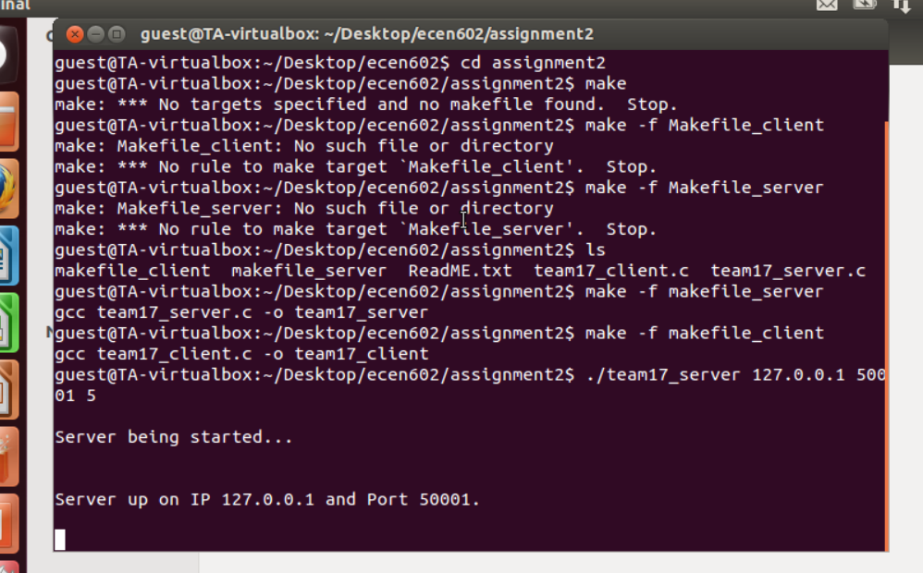

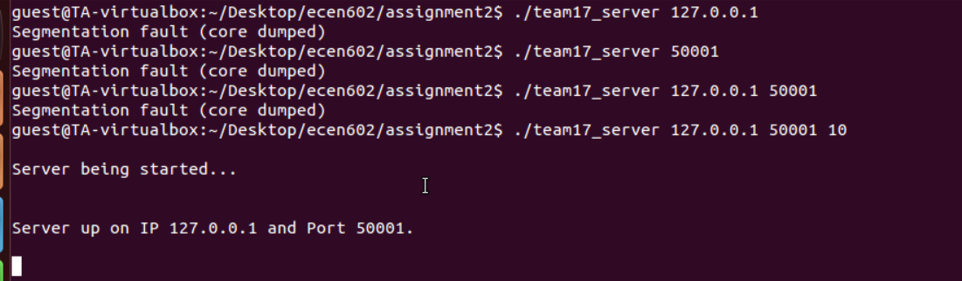

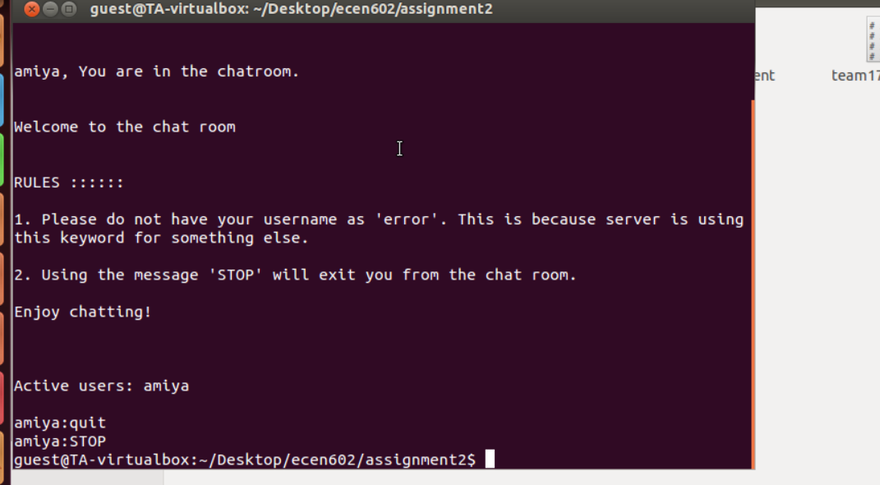

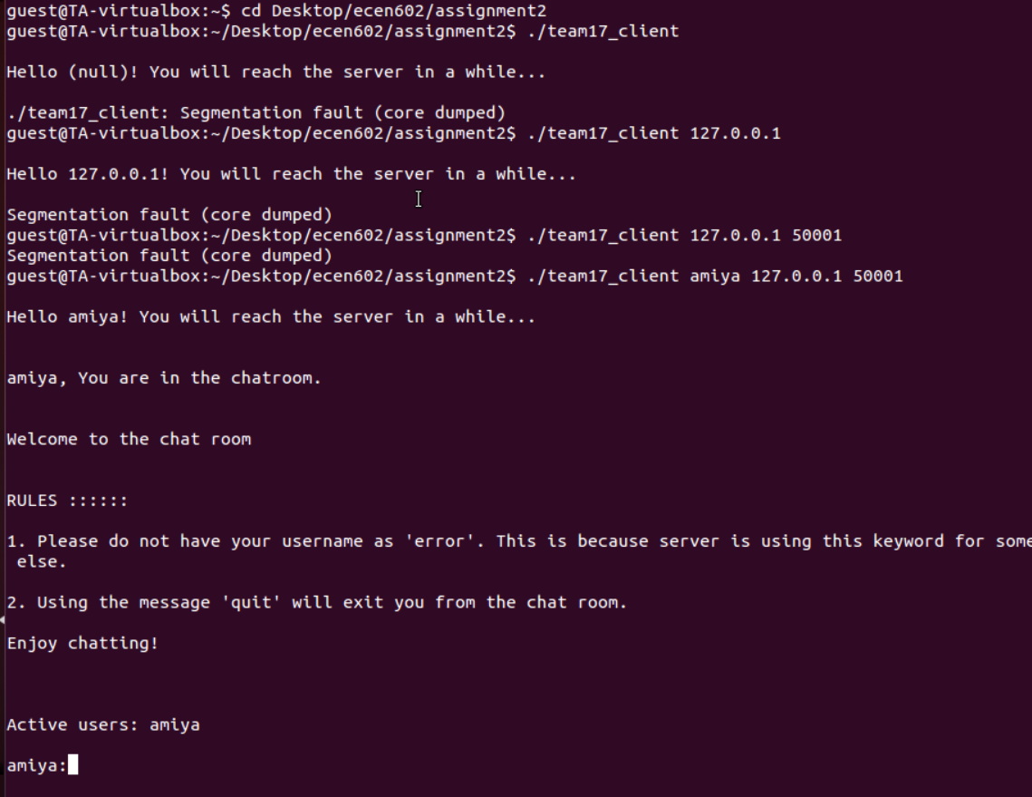

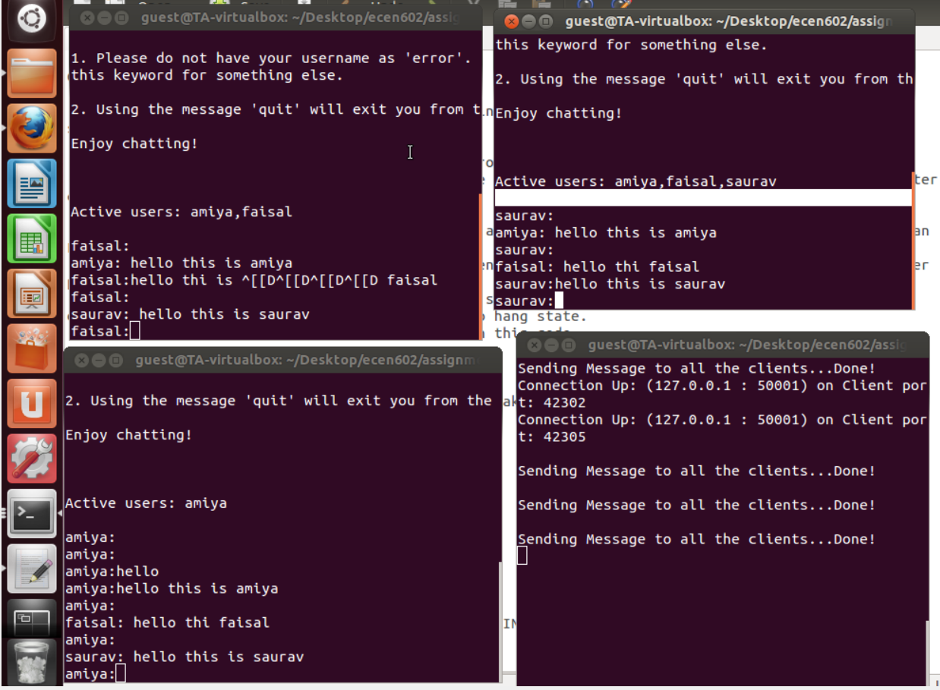

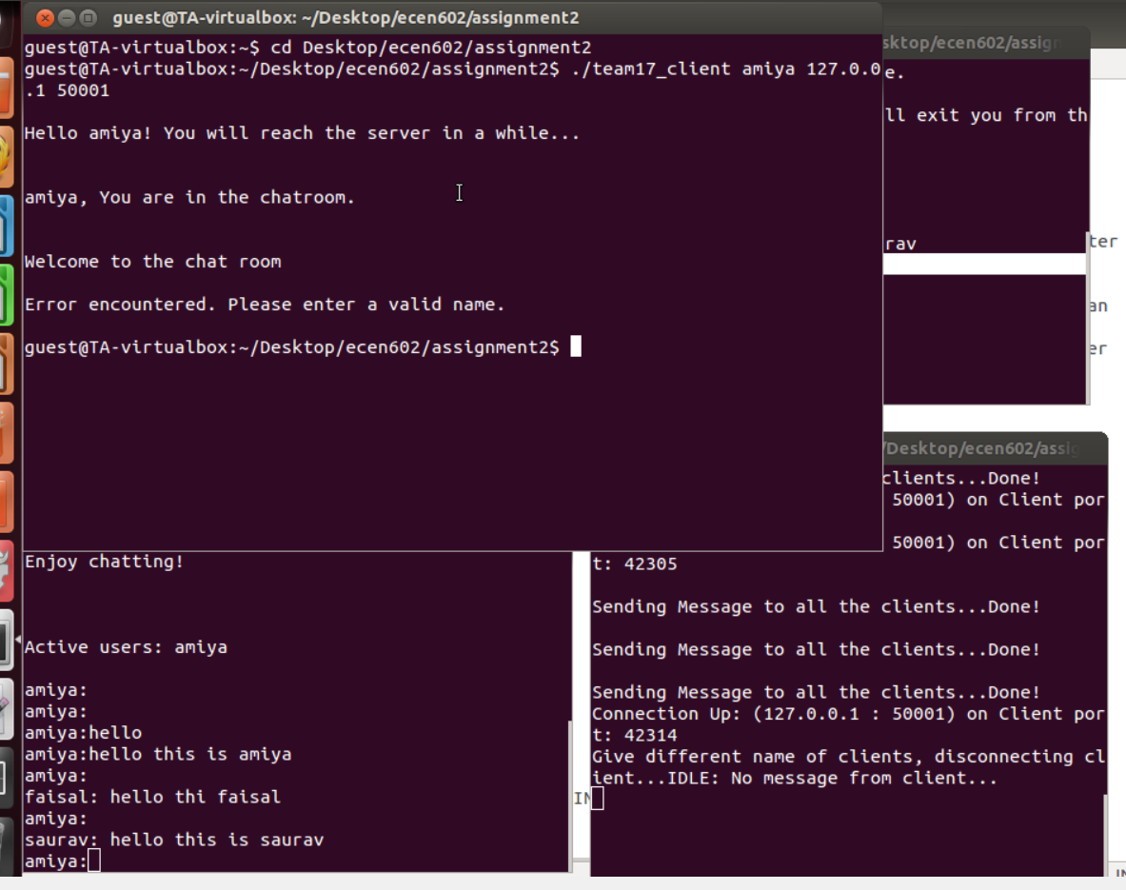

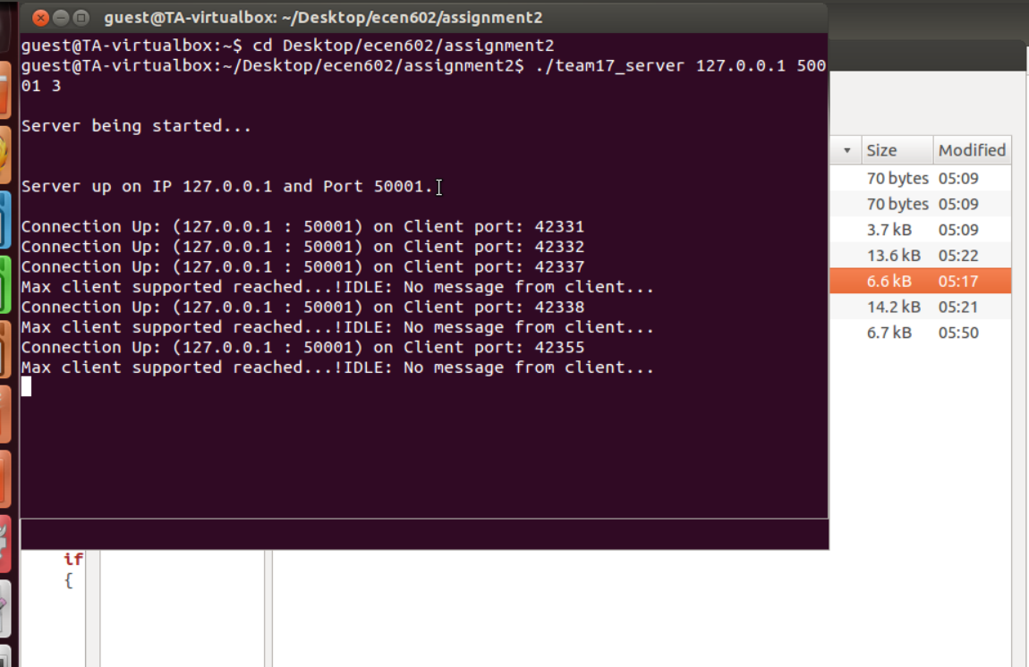

TCP CHAT SERVER CODE ::

# include <stdio.h>

# include <string.h>

# include <sys/types.h>

# include <netinet/in.h>

# include <sys/socket.h>

# include <stdlib.h>

# include <arpa/inet.h>

# include <unistd.h>

# include <netdb.h>

/* Global Structures */

int count;

void reply_join(int socket_fd1, int argv3);

char users[1024];

struct attr_payload

{

char client_usrname[16];

char message[512];

char reason[32];

int client_count;

}a_payload;

struct attr_sbcp

{

int attr_type;

int attr_length;

struct attr_payload sbcp_attr_payload;

}msg_username, msg, msg_reason;

struct msg_sbcp

{

int ver;

int msg_type;

int msg_length;

struct attr_sbcp msg_payload[4];

}final_msg, join_msg;

/* Declarations of used functions */

void connect_server(int *socket_fd,struct sockaddr_in *serv_addr,int argv2, int argv3, char argv1[4]);

void accept_new_client(fd_set *main_set, int *max_fd, int socket_fd, struct sockaddr_in *client_addr, char argv2[10], int argv3);

void send_receive_data(int num, fd_set *main_set, int socket_fd, int max_fd);

void broadcast_data (int count, int num, int socket_fd, int recvd_bytes, struct msg_sbcp receive_buffer, fd_set *main_set);

void delete_client(fd_set *main_set, int *max_fd, int socket_fd, struct sockaddr_in *client_addr, char argv2[10], int argv3);

int main(int argc, char *argv[])

{

struct sockaddr_in serv_addr, client_addr;

fd_set main_set;

fd_set temp_set;

int max_fd;

int i;

int argv2=atoi(argv[2]);

int argv3=atoi(argv[3]);

int socket_fd=0;

FD_ZERO(&main_set);

FD_ZERO(&temp_set);

connect_server(&socket_fd, &serv_addr,argv2,argv3,argv[1]);

FD_SET(socket_fd, &main_set);

max_fd=socket_fd;

fflush(stdout);

printf("\nServer being started...\n\n");

fflush(stdout);

sleep(1);

fflush(stdout);

printf("\nServer up on IP %s and Port %s.\n\n",argv[1], argv[2]);

fflush(stdout);

while(1)

{

temp_set=main_set;

if(select(max_fd+1,&temp_set,NULL,NULL,NULL)==-1)

{

error("Error in select()..!");

exit(4);

}

for(i=0;i<=max_fd;i++)

{

if(FD_ISSET(i, &temp_set))

{

if(i==socket_fd)

{

accept_new_client(&main_set,&max_fd,socket_fd,&client_addr,argv[2],argv3);

}

else

send_receive_data(i,&main_set,socket_fd,max_fd);

}

}

}

return 0;

}

void connect_server(int *socket_fd,struct sockaddr_in *serv_addr, int argv2,int argv3, char argv1[4])

{

if((*socket_fd = socket(AF_INET,SOCK_STREAM,0))==-1)

error("Error in socket()..!");

serv_addr->sin_family = AF_INET;

serv_addr->sin_port = htons(argv2);

serv_addr->sin_addr.s_addr = inet_addr(argv1);

memset(serv_addr->sin_zero, '\0', sizeof serv_addr->sin_zero);

int flag=1;

if(setsockopt(*socket_fd,SOL_SOCKET,SO_REUSEADDR,&flag,sizeof(int))==-1)

{

error("Error in socket opt()...\n");

exit(1);

}

if(bind(*socket_fd, (struct sockaddr *)serv_addr, sizeof (struct sockaddr))==-1)

{

error("Error in bind()...\n");

exit(1);

}

if(listen(*socket_fd,argv3) == -1)

{

error("Error in listen()...\n");

exit(1);

}

}

void accept_new_client(fd_set *main_set, int *max_fd, int socket_fd, struct sockaddr_in *client_addr,char argv2[10], int argv3)

{

int new_socket_fd;

socklen_t length;

length=sizeof(struct sockaddr_in);

if((new_socket_fd=accept(socket_fd,(struct sockaddr*)client_addr,&length))==-1)

{

error("Client error... Cannot accept...");

exit(1);

}

else

{

FD_SET(new_socket_fd,main_set);

if(new_socket_fd>*max_fd)

{

*max_fd=new_socket_fd;

}

printf("Connection Up: (%s : %s) on Client port: %d\n",inet_ntoa(client_addr->sin_addr),argv2,ntohs(client_addr->sin_port));

int new_socket_fd1=new_socket_fd;

reply_join(new_socket_fd1,argv3);

}

}

void send_receive_data(int num, fd_set *main_set, int socket_fd, int max_fd)

{

int recvd_bytes;

memset(&final_msg, 0, sizeof(final_msg));

if((recvd_bytes= recv(num, &final_msg, sizeof(final_msg), 0)) > 0)

{

int count;

for(count=0;count<=max_fd;count++)

{

broadcast_data(count,num,socket_fd,recvd_bytes,final_msg,main_set);

}

fflush(stdout);

printf("\nSending Message to all the clients...Done!\n");

fflush(stdout);

}

else

{

if(recvd_bytes==0)

{

printf("IDLE: No message from client...\n", num);

}

else

{

error("Error in data sent...");

}

close(num);

FD_CLR(num,main_set);

}

}

void reply_join(int socket_fd1, int argv3)

{

int recvd_bytes;

memset(&join_msg, 0, sizeof(join_msg));

if((recvd_bytes= recv(socket_fd1, &join_msg, sizeof(join_msg), 0)) <=0)

{

if(recvd_bytes==0)

{

printf("Socket not replying...", socket_fd1);

}

else

{

error("Error in received bytes...");

}

close(socket_fd1);

}

char name[16];

strcpy(name,join_msg.msg_payload[0].sbcp_attr_payload.client_usrname);

if(strstr(users,name))

{

fflush(stdout);

printf("Give different name of clients, disconnecting client...");

fflush(stdout);

char error[]="error_name";

send(socket_fd1,error,strlen(error),0);

memset(&join_msg, 0, sizeof(join_msg));

}

else

{

if(count<argv3-1)

{

strcat(users,join_msg.msg_payload[0].sbcp_attr_payload.client_usrname);

int m=strlen(users);

send(socket_fd1,users,strlen(users),0);

users[m]=',';

memset(&join_msg, 0, sizeof(join_msg));

count++;

}

else

{

printf("Max client supported reached...!");

fflush(stdout);

char error[]="error_max";

send(socket_fd1,error,strlen(error),0);

memset(&join_msg, 0, sizeof(join_msg));

}

}

}

void broadcast_data (int count, int num, int socket_fd, int recvd_bytes, struct msg_sbcp final_msg, fd_set *main_set)

{

if(FD_ISSET(count,main_set))

{

if(count!=socket_fd && count!=num)

{

if(send(count,&final_msg,recvd_bytes,0)==-1)

{

error("Error in send()...");

}

memset(&final_msg, 0, sizeof(final_msg));

}

}

}

TCP CHAT CLIENT CODE –

# include <stdio.h>

# include <string.h>

# include <sys/types.h>

# include <netinet/in.h>

# include <stdlib.h>

# include <unistd.h>

# include <sys/socket.h>

# include <errno.h>

# include <arpa/inet.h>

void cli_conn(int *serv_filedes, struct sockaddr_in *servaddr, int argv3, char argv2[4]);

void sendrecv_info(int i, int serv_filedes, char argv1[16]);

void separate(char buffer[256], char username[16], int serv_filedes);

void consolidate(int serv_filedes, char argv1[16]);

void join(int serv_filedes1, char username[16]);

int main(int argc, char *argv[])

{

struct sockaddr_in servaddr;

int serv_filedes=0;

int max_fd, i;

int argv3=atoi(argv[3]);

fd_set main_set, temp_set;

fflush(stdout);

printf("\nHello %s! You will reach the server in a while...\n\n",argv[1]);

cli_conn(&serv_filedes, &servaddr, argv3, argv[2]);

sleep(1);

fflush(stdout);

printf("\n%s, You are in the chatroom.\n\n", argv[1]);

sleep(1);

printf("\nWelcome to the chat room\n\n");

fflush(stdout);

sleep(1);

sleep(1);

int serv_filedes1=serv_filedes;

join(serv_filedes1,argv[1]);

char user_list[1024]={'\0'};

int l;

l=recv(serv_filedes1,user_list,1024,0);

if(strcmp(user_list,"error_name")==0)

{

printf("Error encountered. Please enter a different name.\n\n");

exit(0);

}

if(strcmp(user_list,"error_max")==0)

{

printf("Error encountered. Maximum users already present in chatroom.\n\n");

exit(0);

}

printf("\nRULES ::::::\n\n");

printf("1. Please do not have your username as 'error'. This is because server is using this keyword for something else.\n\n");

printf("2. Using the message 'STOP' will exit you from the chat room.\n\n");

printf("Enjoy chatting!\n\n");

printf("\n\nActive users: %s\n\n",user_list);

FD_ZERO(&main_set);

FD_ZERO(&temp_set);

FD_SET(0,&main_set);

FD_SET(serv_filedes,&main_set);

max_fd=serv_filedes;

fflush(stdout);

printf("%s:",argv[1]);

fflush(stdout);

while(1)

{

temp_set=main_set;

if(select(max_fd+1,&temp_set,NULL,NULL,NULL)==-1)

{

error("Cannot select()");

exit(4);

}

for(i=0;i<=max_fd;i++)

{

if(FD_ISSET(i,&temp_set))

{

sendrecv_info(i,serv_filedes,argv[1]);

}

}

}

return 0;

}

void separate(char buffer[256], char username[16], int serv_filedes)

{

int buff_len=strlen(buffer);

int user_len=strlen(username);

struct attr_payload

{

char client_username[16];

char message[512];

char reason[32];

int client_count;

};

struct sbcp_attribute

{

int attribute_type;

int attribute_length;

struct attr_payload sbcp_payload;

}msg_username, msg, msg_reason;

struct sbcp_message

{

int ver;

int msg_type;

int msg_length;

struct sbcp_attribute msg_payload[4];

}final_msg,join_msg;

memset(&final_msg, 0, sizeof(final_msg));

strcpy(msg_username.sbcp_payload.client_username,username);

msg_username.attribute_type=2;

msg_username.attribute_length=user_len+2+2;

strcpy(msg.sbcp_payload.message,buffer);

msg.attribute_type=4;

msg.attribute_length=buff_len+2+2;

final_msg.ver=3;

final_msg.msg_type=4;

final_msg.msg_length=sizeof(msg_username)+sizeof(msg)+2+2;

final_msg.msg_payload[0]=msg_username;

final_msg.msg_payload[1]=msg;

send(serv_filedes, &final_msg,sizeof(final_msg),0);

memset(&final_msg, 0, sizeof(final_msg));

fflush(stdout);

printf("%s:",username);

fflush(stdout);

}

void sendrecv_info(int i, int serv_filedes, char argv1[16])

{

char send_buffer[256];

char receive_buffer[256];

int received_bytes;

if(i==0)

{

fgets(send_buffer,256,stdin);

if(strcmp(send_buffer,"STOP\n")!=0)

separate(send_buffer,argv1,serv_filedes);

else

exit(0);

fflush(stdout);

}

else

{

consolidate(serv_filedes, argv1);

}

}

void consolidate(int serv_filedes, char argv1[16])

{

struct attr_payload

{

char client_username[16];

char message[512];

char reason[32];

int client_count;

};

struct sbcp_attribute

{

int attribute_type;

int attribute_length;

struct attr_payload sbcp_payload;

};

struct sbcp_message

{

int ver;

int msg_type;

int msg_length;

struct sbcp_attribute msg_payload[4];

}final_msg;

int received_bytes;

char receive_buffer[256];

received_bytes=recv(serv_filedes, &final_msg, sizeof(final_msg),0);

strcpy(receive_buffer,final_msg.msg_payload[1].sbcp_payload.message);

receive_buffer[received_bytes]='\0';

printf("\n%s: %s",final_msg.msg_payload[0].sbcp_payload.client_username,receive_buffer);

fflush(stdout);

printf("%s:",argv1);

fflush(stdout);

memset(&final_msg, 0, sizeof(final_msg));

fflush(stdout);

}

void cli_conn(int *serv_filedes, struct sockaddr_in *servaddr, int argv3, char argv2[4])

{

if((*serv_filedes=socket(AF_INET,SOCK_STREAM,0))==-1)

{

error("Cannot create socket.");

exit(1);

}

servaddr->sin_family=AF_INET;

servaddr->sin_port=htons(argv3);

servaddr->sin_addr.s_addr=inet_addr(argv2);

memset(servaddr->sin_zero,'\0',sizeof servaddr->sin_zero);

if(connect(*serv_filedes,(struct sockaddr *) servaddr, sizeof(struct sockaddr))==-1)

{

error("Failed to connect to socket.");

exit(1);

}

}

void join(int serv_filedes1, char username[16])

{

int user_len=strlen(username);

struct attr_payload

{

char client_username[16];

char message[512];

char reason[32];

int client_count;

};

struct sbcp_attribute

{

int attribute_type;

int attribute_length;

struct attr_payload sbcp_payload;

}msg_username, msg, msg_reason;

struct sbcp_message

{

int ver;

int msg_type;

int msg_length;

struct sbcp_attribute msg_payload[4];

}join_msg;

memset(&join_msg, 0, sizeof(join_msg));

strcpy(msg_username.sbcp_payload.client_username,username);

msg_username.attribute_type=2;

msg_username.attribute_length=user_len+2+2;

join_msg.ver=3;

join_msg.msg_type=2;

join_msg.msg_length=sizeof(msg_username)+2+2;

join_msg.msg_payload[0]=msg_username;

send(serv_filedes1, &join_msg,sizeof(join_msg),0);

memset(&join_msg, 0, sizeof(join_msg));

}